**ENTEBBE BRIGHT SECONDARY SCHOOL NKUMBA -KISEMBI**

**GEOGRAPHY EXAMINATION**

**S.4**

**Instructions.**

**Answer all items in this paper**

**TIME. 2 HOUR**

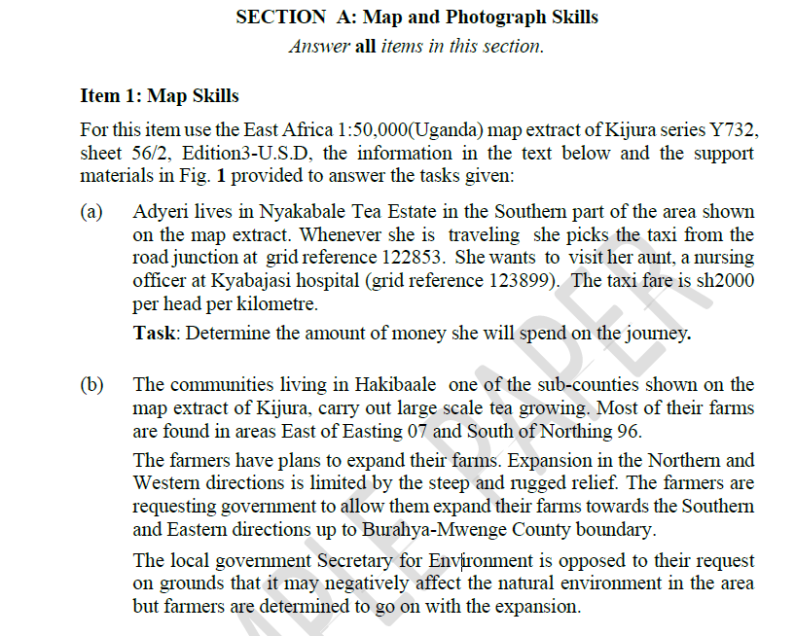

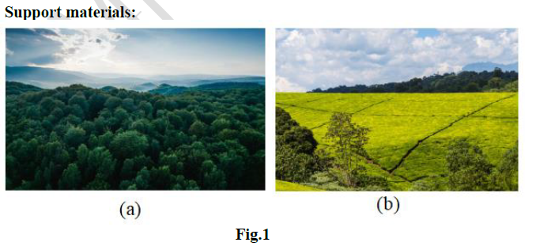

**Task:**

Using evidence from the map extract and the support materials provided, explain the kind of advice you would give to the farmers about their planned expansion of tea farms

**ITEM 2: PHOTOGRAPH SKILLS**

Study the photograph taken from one of the places in eastern Uganda and the text provided below it.

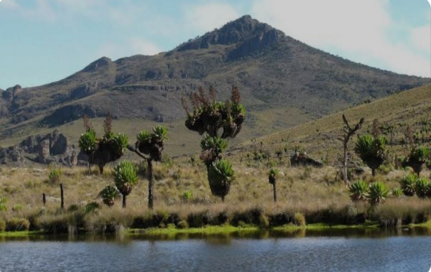

Eastern Uganda has got a diverse features and landforms that resulted from different processes and Mt. Elgon is one of the beautiful Mountains found in a certain place in Eastern Uganda, a group of students have come from Burundi to study about the formation of mountain Elgon. However, they chose Entebbe bright students because of their brilliancy and being knowledgeable about landforms in East Africa, the whole school suggested that S.4 will be able to teach their fellow learners.

Task:

(a)Draw a landscape sketch of the photograph and on it mark and name the features found in the area shown in the photo.

(b)Describe for the visitors activities they will engage in when they visit the area. Give evidence from the photograph.

(c) Briefly tell your fellow learners how mountain Elgon was formed.

**SECTION B**

**This section has two parts I and II.**

**Part I**

**Answer one item from this part**

**Item 3**

The name Nairobi comes from the Masai sentence “Enkare Nairobi” meaning the cold water. This Nairobi was a name of a river in Masai language meaning that the city is extended around this river. According to the 2012 census, Nairobi had a population of 3,138,295 inhabitants living on an area of 696 km2. Although Nairobi has remarkable records in terms of economic development, the city has many challenges.

**Support materials**

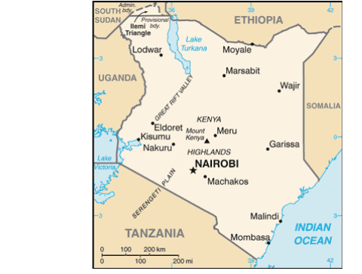

**Task:**

Suppose you are one of the urban planners, design an article of about 500 to be published in east African newspaper that would address the consequences of the phenomenon.

**Item 4**

Vegetation is important to man in various ways and it acts as a habitat place for wild animals. There is need to conserve it due to its significance. The different countries have come up with environmental campaigns aimed at protecting the natural vegetation for the environment and sustainability.

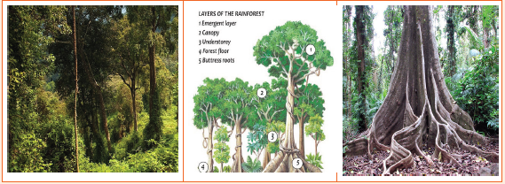**Support materials**

**Task :**

Write an essay explaining to the local community why it’s important to conserve the natural vegetation

**Part II**

*Answer* **one** *item from this part.*

**Item 5.**

Noting that it had been decided to develop a framework for forestry issues that would apply to the entire continent, she said it was important to ensure that productivity of existing agricultural land could be enhanced so that there was no need to cut down further trees to increase farm land. Madam Dlamini-Zuma said the AU was working hard to “get more energy into Africa” to minimize reliance on wood. You have been invited for a conference on a theme “Africa Leads Global Deforestation”.

**Support material**

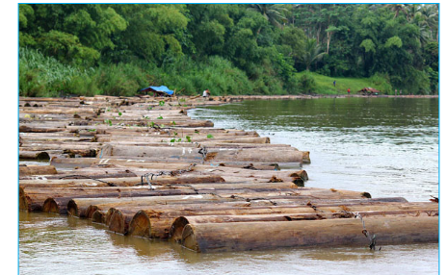

**Task:**

Prepare a written speech of about 500 words which you will present in the conference.

**Item 6**

Most of the industrial products used in developing countries are imported from Europe, USA, and ASIA. They also export agricultural products to the rest of the world but the gap between imports and exports in less developed countries still remains big.

**Support material**

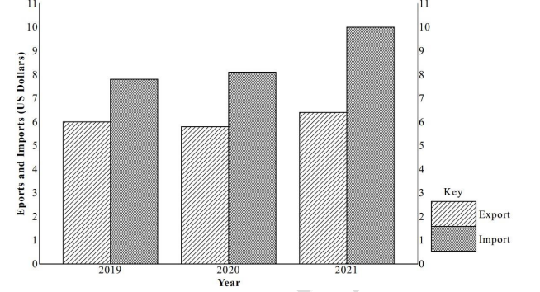**COMPARATIVE BAR GRAPH SHOWING COUNTRY X’S INTERNATIONAL TRADE FOR YEARS 2019 AND 2021**

Task:

1. Using evidence from the graph only, explain the likely factors for this inequality between exports and imports.
2. Advise traders in your country on how they can contribute towards improving the country’s inequality between exports and imports.